3.4 OPFOR – Non-Linear Subject Matter Expert (SME)
Mr. Chris HUGHES
Technical Requirements and Evaluation Matrix
Technical Requirement | Meets:  Y or N | Bidder shall complete each section below outlining how compliance is achieved and specifically reference the information which demonstrates compliance with the criteria
1. Higher-level Civilian, Military or Staff College Education/Degree relevant to Intelligence, Law or International Affairs or related subjects and/or 8 years previous military or civilian experience in the Operational Intelligence or Special Forces domain |  | Mr. Chris HUGHES has 14 years’ experience as a commissioned officer in the British Army working in Intelligence, ISR, Info Ops and Human Terrain analysis. 11 regular and 4 reserve.  He has the following education degrees:  - Intermediate Command and Staff College (Land Reserve)  - Visiting Research Fellowship at the University of Oxford Changing Character of War Centre.  Unequivocal reference evidenced by:  CV Section 4,5  Index of supporting documents # 1, 2,6
2. Minimum 8 years previous military or civilian experience within the last 12 years in the OPERATIONAL INTELLIGENCE or SPECIAL FORCES domain reaching the rank of OF3/OF4 (or civilian equivalent). |  | Mr. Chris HUGHES has more than 8 years of military or civilian experience within the last 12 years in the OPERATIONAL INTELLIGENCE or SPECIAL FORCES domain reaching the rank of OF3/OF4 as described follows:  - 2013 - 2015: Intelligence integration at BG level  - 2015-2019: Intelligence (Human Terrain) analysis and advice.  - 2019-2020: Special project at UKSF (Reserves)  - 2021-2022: Collection Management at Defence Intelligence  Currently serving as Major (OF3) in British Army Reserves.  Unequivocal reference evidenced by:  CV Section 3, 4,5
3. 3 years military or civilian experience as a OF3-OF4 (or civilian equivalent) in one of the following positions:  a. Senior Field Agent  b. Supervisory Special Agent c. Special Agent in Charge  d. Senior Case Officer  e. Senior Analyst in a NATO or national Military or Civilian Intelligence or Security Police Agency or NATO or national Special  Forces domain equivalent to a 2* HQ or higher |  | Mr. Chris HUGHES had a Senior Analyst role at the British Army DCSU (Defence Cultural Specialist Unit) as senior OF2 including acting OF3 responsibilities from 2016 to 2019.  In addition, he had 1 year at Defence Intelligence as senior OF2 in Collection Management.  Unequivocal reference evidenced by:  CV Section 4,5
4. Competent and Qualified in Link Analysis databases and software applications including ‘I-Base’ and ‘I2 |  | Mr. Chris HUGHES has significant experience with Tableau and other data analysis tools and basic with I-Base or I2 software applications.  Unequivocal reference evidenced by:  CV Section 4,5
5. Working knowledge of Hybrid threats at the operational or strategic level. |  | Mr. Chris HUGHES is UK MOD Joint Information Operations Course qualified.  He has conducted Collection Requirements for counter hybrid threat operations at UK Defence Intelligence.  Visiting Research Fellowship, University of Oxford on Information Operations.  He has conducted a Grey Zone study whilst at the Defence Cultural Specialist Unit as part of the unit’s subordination to 77X (Information Operations Brigade)  Unequivocal reference evidenced by:  CV Section 4,5  Index of supporting documents # 5
6. Competent in Microsoft Word, Excel and PowerPoint |  | Mr. Chris HUGHES is very competent in Microsoft Word, Excel and PowerPoint. He has an VBA and macro experience in Excel for automation tasks.  Unequivocal reference evidenced by:  CV Section 4,5
7. Current NATO Secret Security Clearance. |  | Mr. Chris HUGHES holds a NATO SECRET security clearance (valid until 2033)  Unequivocal reference evidenced by:  Index of supporting documents # 4
8. Demonstrated proficiency in English as defined in STANAG 6001 (Standardized Linguistic Profile (SLP) 3333 – Listening, Speaking, Reading, and Writing) or equivalent. |  | Mr. Chris HUGHES is a native speaker

Chris HUGHES
SECTION 1: Profile

- Chris Hughes is an experienced trainer and consultant with 11 years of regular British Army service and 5 years of experience as a contractor supporting collective training and intelligence capacity building. He is also a serving Army Reservist (Major)
- He has designed and delivered courses internationally, including for the Nigerian Armed Forces and the Chilean Centre for UN Peacekeeping Operations, and supported major UK exercises in ISR, CIMIC and Media/Information Operations roles and most recently supported NATO as JISR Manager on NATO exercise STEADFAST DUEL 2025 (STDU25).
- He is qualified in ISR, Human Security, Info Ops and experienced in analysis in academic, military and corporate contexts.
- Holder of NATO SECRET security clearance (valid until 10/10/ 2033). Citizen of a NATO nation - UK
SECTION 2: Key Personal Attributes

- Analytical and dynamic trainer with a strong record of delivering complex training and advisory tasks under pressure on exercises and operations.
- Experienced in NATO and UK Defence exercise environments in a variety of staff roles.
- Deep understanding of intelligence processes, collection management, and human security within multinational contexts.
- Skilled in research, analysis and presentation; capable of converting complex intelligence requirements into actionable outputs.
- Experienced working with international organisations, including the UN and host-nation forces, fostering cooperation and trust.
- Strong communication, stakeholder management and report-writing skills.
- Experienced in EXCON, HICON and OPFOR.

SECTION 3: Relevant skills and experience

Extensive experience in intelligence training design, exercise support and ISR consultancy across NATO and partner-nation contexts:
Currently: Major (OF3), Outreach Group, (Army Special Operations Brigade) Human Security, CIMIC, Gender and Security Force Assistance expertise in support of Army exercises.
Oct 25: JWC, Contractor. Ex STDU25 JISR, Collection Manager for the NIFC/ INTEL section.
Sept - Oct 25: Jordan, Consultant. ISR Capacity building.
Aug - Sept 25: Land Warfare Centre (UK), Ex HYPERION WARRIOR (British Army Special Operations Brigade Training), OPFOR INFOWAR (Info Ops/Media)
Dec 24 - Mar 25: Nigeria, Contractor. Intelligence capacity building, designing and delivering Intelligence courses for Defence Intelligence College Abuja.
Oct 24: Germany, Contractor. Ex CERBERUS 24 (British Army Divisional training), OPFOR ISR Staff Officer.
Jun - Jul 24: UK, Student. Intermediate Command and Staff College (Land Reserve)
Nov 23: Land Warfare Center, Contractor. Ex LAND WARRIOR 23 (British Army Divisional Training), HICON CIMIC Staff Officer.
British Army Exercises and Operations at the operational and strategic level during uniformed service;
- 2022, Op SCORPIUS (British Support to Ukraine during Russian invasion)
- 2019 Ex WARFIGHTER 19.4 - US Corps Level training event
- 2017 Ex WARFIGHTER 17.5 (Ft Bragg)- US Corps Level training event
- 2015 Ex IRON RESOLVE - British Divisional Training event
- 2013-14 Op HERRICK 19 - Afghanistan

Proficient in the use of NATO Community of Interest Systems and tools such as JEMM, INTELFS.

Technical Skills - advanced MS Office user (Excel/VBA automation), familiar with ISR and intelligence software.
SECTION 4: Career Summary

Jun 2024 - Present Major (OF3), Joint CIMIC Group, (Army Special Operations Brigade)
Human Security, CIMIC, Gender and Security Force Assistance expertise in support of Army exercises.
Oct 25: Contractor - JWC, Ex STDU25. JISR Collection Manager for the INTEL section.
Managed Collection requirement responses and analysts generating simulated products for training audiences as part of the INTEL team simulating NIFC.
Sept - Oct 25: Consultant - ISR Capacity Building, ARK, Jordan
Conducted a study for the Jordanian Public Security Directorate’s Anti-Narcotics Department on how UAS can support ISR operations. Led interviews, analysis and advisory outputs to inform future capability development.
Aug - Sept 25: Contractor, Land Warfare Centre (UK), Ex HYPERION WARRIOR (British Army Special Operations Brigade Training). OPFOR INFOWAR (Info Ops)
Planned and delivered OPFOR media and information operations to generate a realistic wrap for the training audience.
Dec 24 - Mar 25: Training Contractor - Facilitator, TAG International
Delivered leadership and critical thinking training for the Nigerian Armed Forces. Designed and facilitated modules on human security, intelligence and leadership development.
Oct 24: Contractor, Germany. Ex CERBERUS 24 (British Army Divisional training), OPFOR ISR Staff Officer.
Staff Officer for OPFOR ISR conducting planning and operations for Operational level scenario to train 1(UK) Division.
Feb - Aug 23: Space Ecosystem Manager, Satellite Applications Catapult
Developed relationships across the UK Space sector, connecting industry, academia and local government to drive regional innovation.
Apr 2022 - Feb 2023: Business Management Consultant, BlackRock Alternatives
Improved business processes and technology supporting sales teams across investment asset classes. Managed multiple concurrent projects and delivered automation solutions for efficiency.
Feb 2021 - Apr 2022: Collection Manager (Russia Team Lead), UK Ministry of Defence
Managed intelligence requirements during the invasion of Ukraine. Led a team of 25 analysts, developed a VBA-based automation tool streamlining Defence Intelligence’s task management RFI-IRM-CM workflow. Also lead the departments support to UKSF..
Jan - Sept 2021: Visiting Research Fellow, Changing Character of War Centre, University of Oxford
Conducted independent research into Venezuelan state information operations. Produced analysis integrating social media data, interviews and academic literature.
Jun - Oct 2020: Training Officer, British Army
Planned and delivered training for mobile COVID-19 testing teams, managing scheduling and field operations.
Jun 2019 - Mar 2021: Project Officer, UKSF (Reserves)
Worked part time on a human terrain project with a reserve unit of UKSF.
Apr 2017 - Dec 2019: Political Advisor for Latin America, British Army
Advised on political and military affairs across Latin America. Contributed to high-profile operations and represented the UK in defence diplomacy initiatives. Concurrently worked as lead human terrain analyst (Cultural Specialist) managing a team of analysts, QCing and contributing to products and writing reports.
Apr 2016 - Apr 2017: UN Peacekeeping Instructor / Assistant Defence Attaché, British Embassy, Chile
Delivered UN peacekeeping courses, lectures and field training. Represented the UK in regional defence forums.
Apr 2012 - Jun 2015: Operations Manager / ISR Team Leader, British Army
Directed 30+ ISR project teams from eight nations collecting intelligence in Afghanistan. Managed operations, training and personnel development for a 33-person team. Wrote and contributed to IMINT products.

SECTION 5: Education and Personal Development/Certifications

- Security Force Assistance Planners course, British Army, 2025
- Cultural Property Protection Course, British Army, 2024
- Intermediate Command and Staff Course, UK Ministry of Defence, 2024
- Defence Human Security Course, UK Ministry of Defence, 2019
- OSINT Course, British Army, 2019
- Cultural Specialist Course, UK Ministry of Defence, 2017
- Spanish Language course, UK Ministry of Defence, 2015-16
- ISTAR Manager’s Course, British Army, 2013
- Commissioning Course 111, Royal Military Academy Sandhurst, 2011
- BSc (hons) Neuroscience, University of Edinburgh, 2009

SECTION 6: LANGUAGE SKILLS

English native speaker, Spanish B2, French B1
SECTION 7: Awards

Operational Service Medal Afghanistan (2013)
Joint Commander’s Commendation for service on Op HERRICK (Afghanistan)

INDEX OF SUPPORTING DOCUMENTS for Maj Chris Hughes
# | DOCUMENTS NAME/SUBJECT
1 | Batchelor of Science Degree certificate
2 | Intermediate Command & Staff Course certificate
3 | STDU 25 certificate of appreciation
4 | CCW website link
5 | UN Peacekeeping Centre CECOPAC certificate
6 | MOD 90 ID Card (Army ID)
7 | NATO SECRET clearance certificate

Index No 1

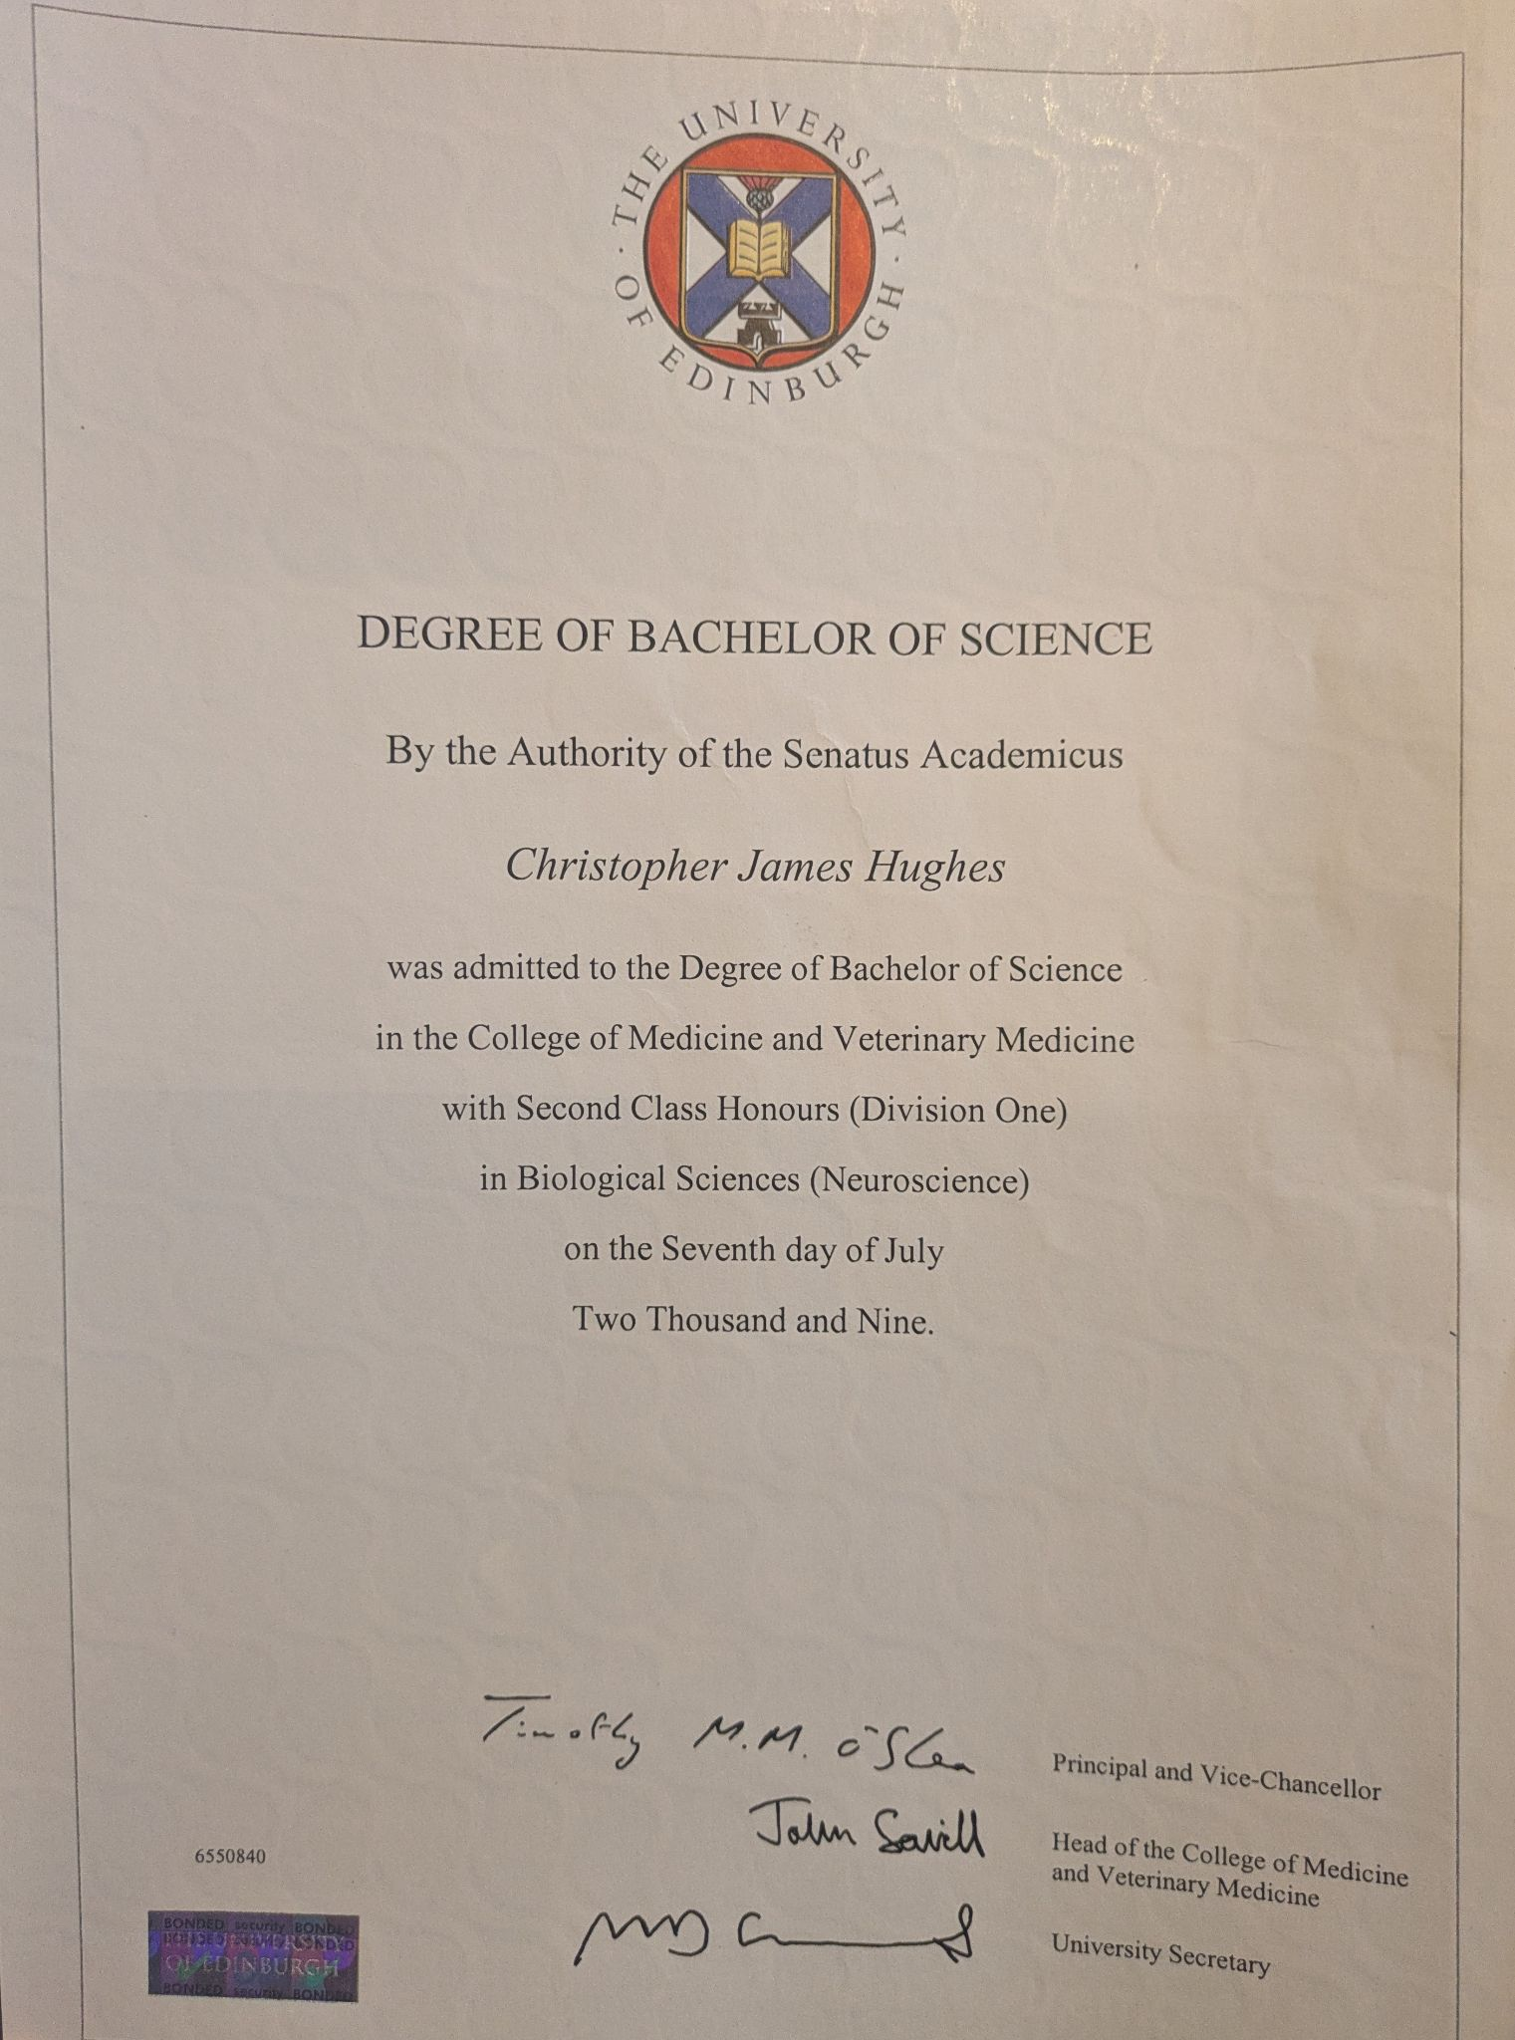

Index No 2

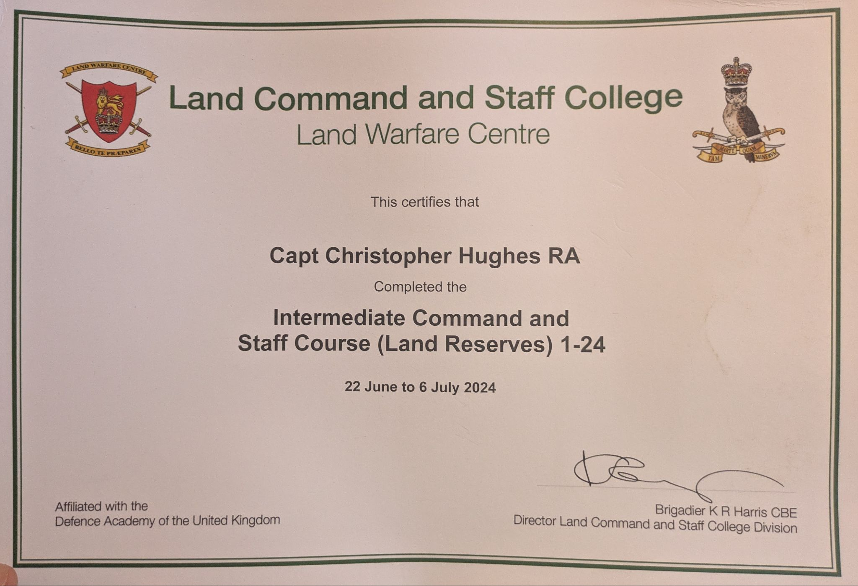
Index No 3

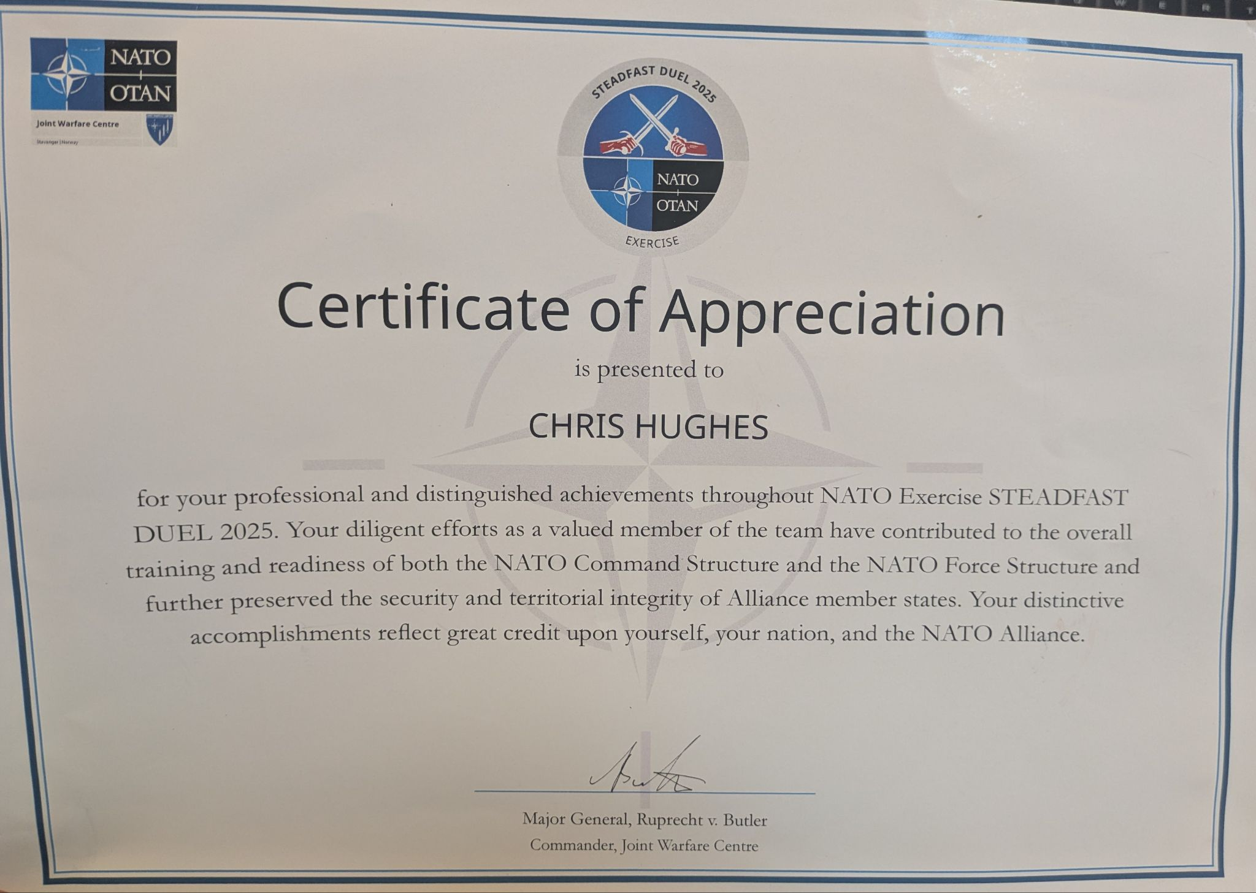

Index No 4

https://www.ccw.ox.ac.uk/visiting-fellows-1

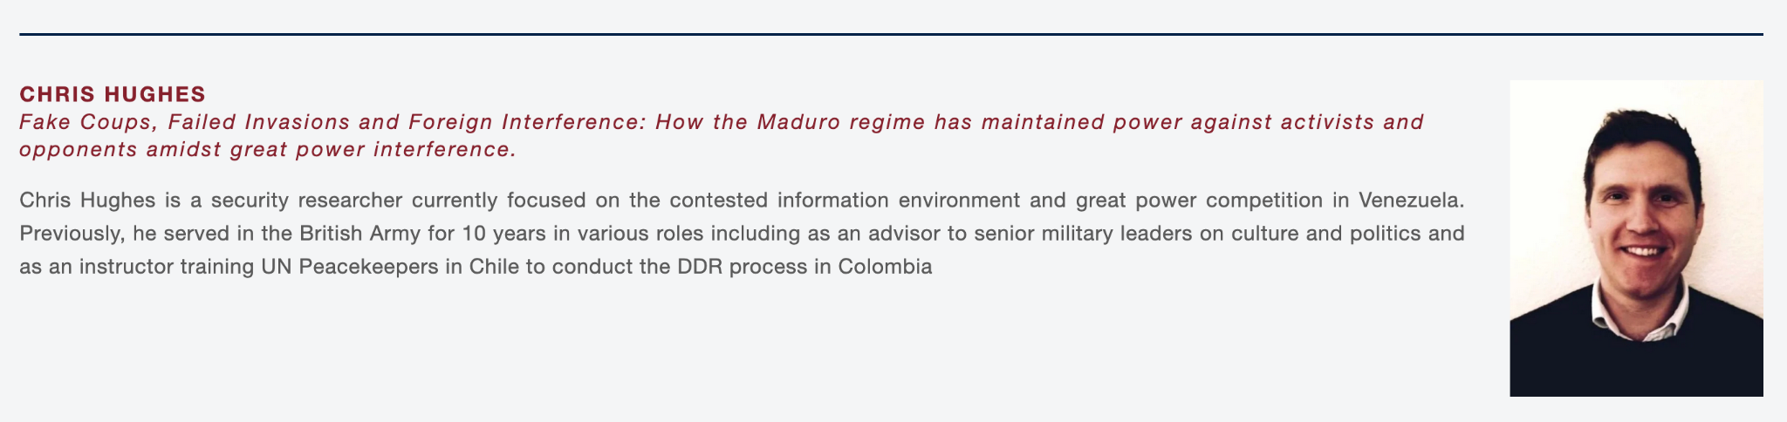

Index No 5

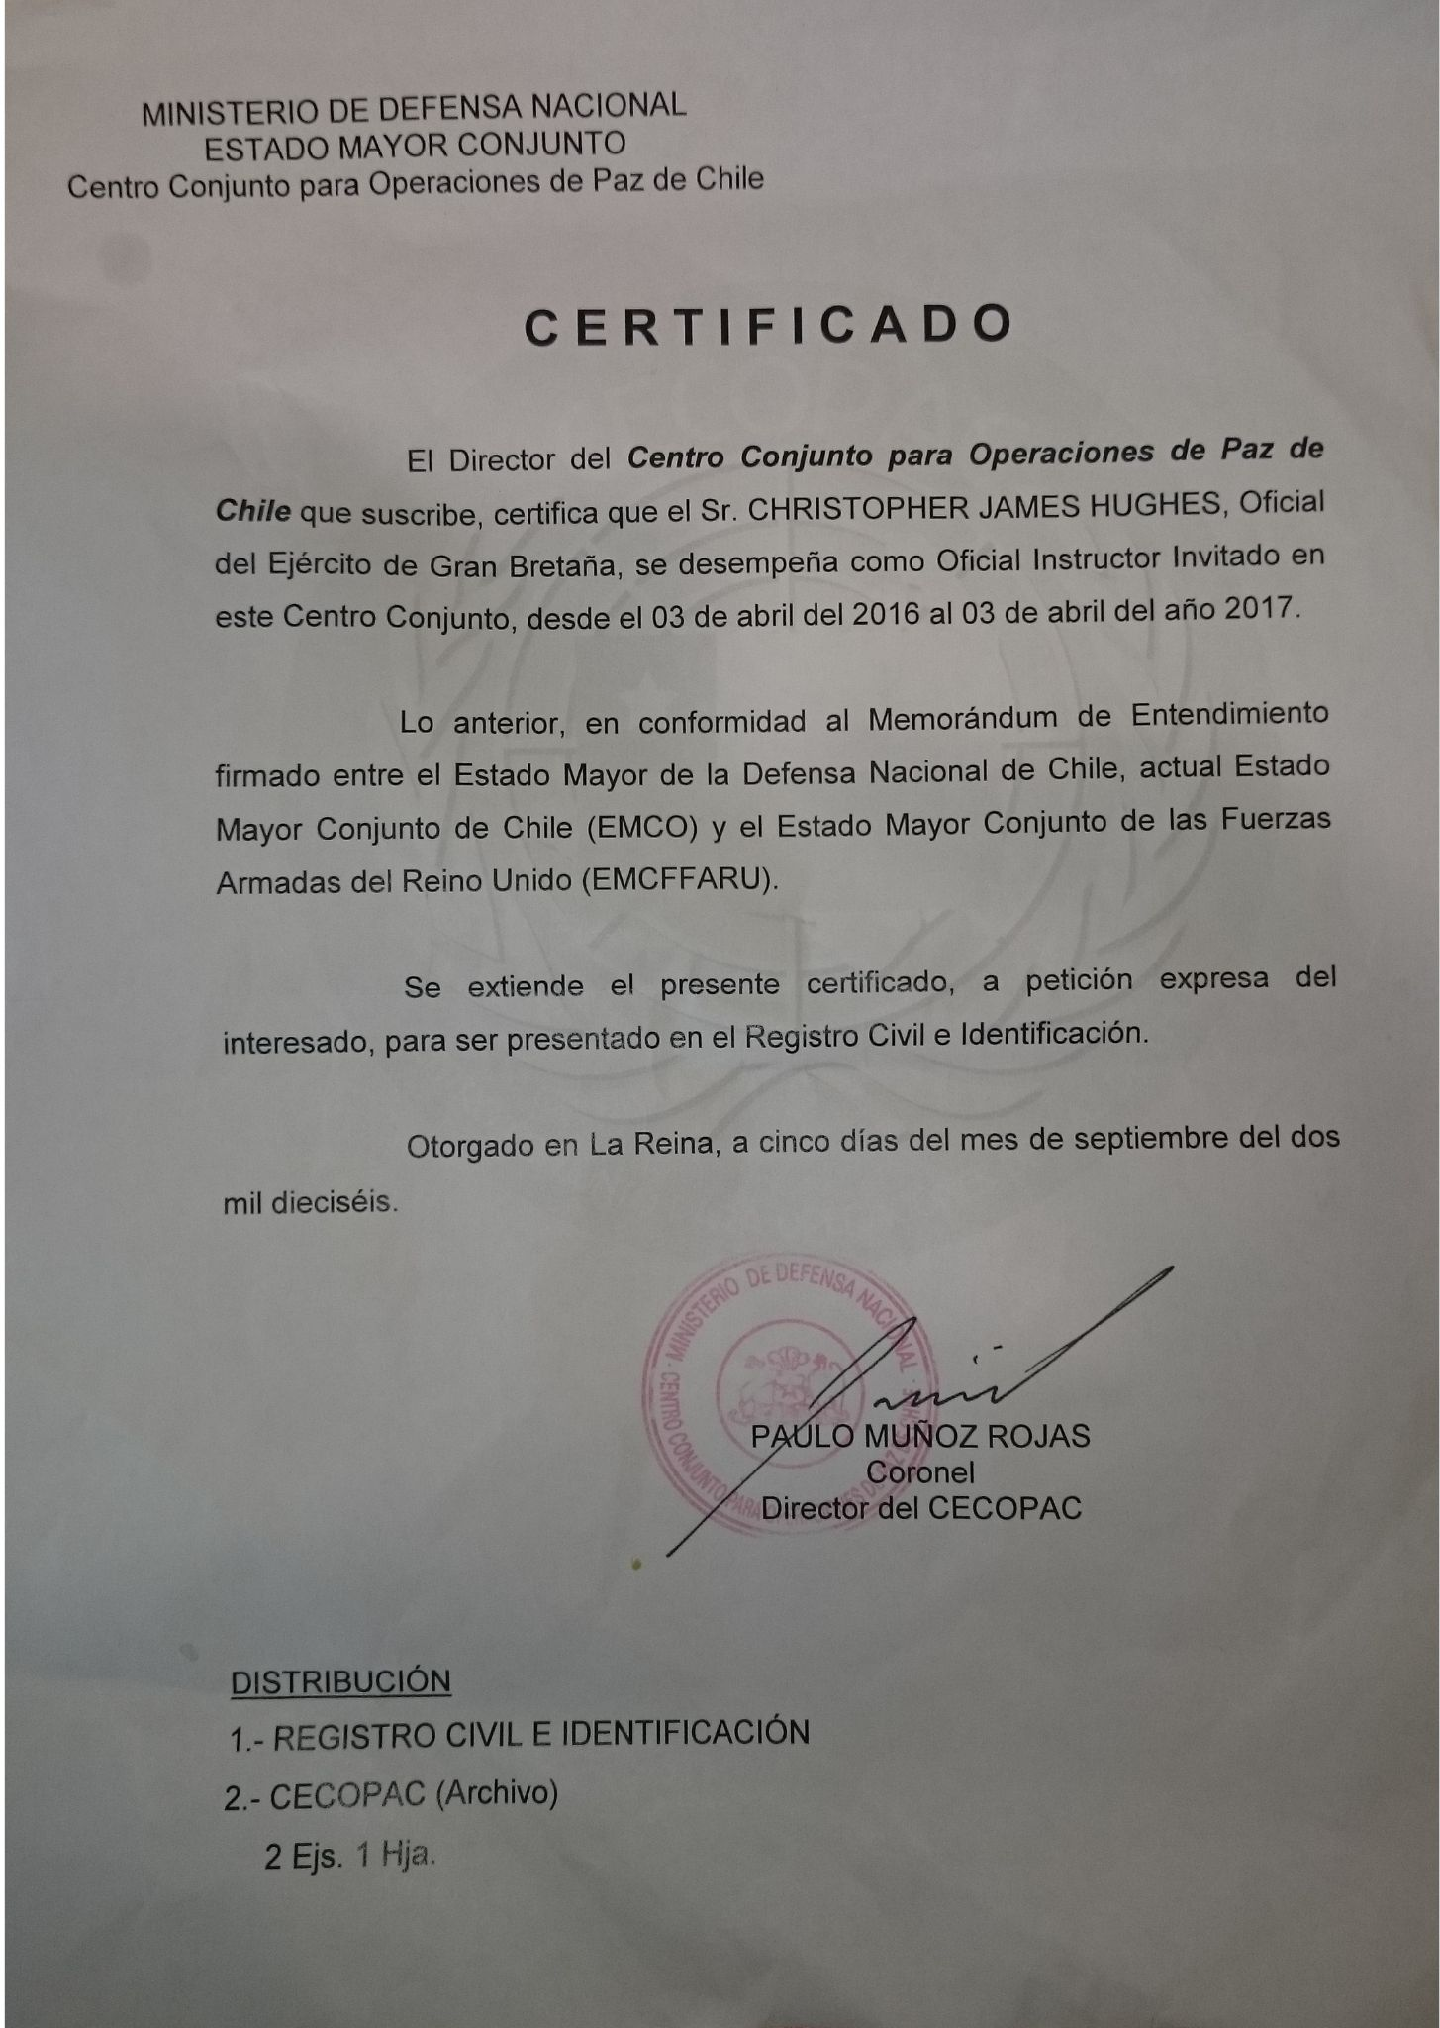
Index No 6

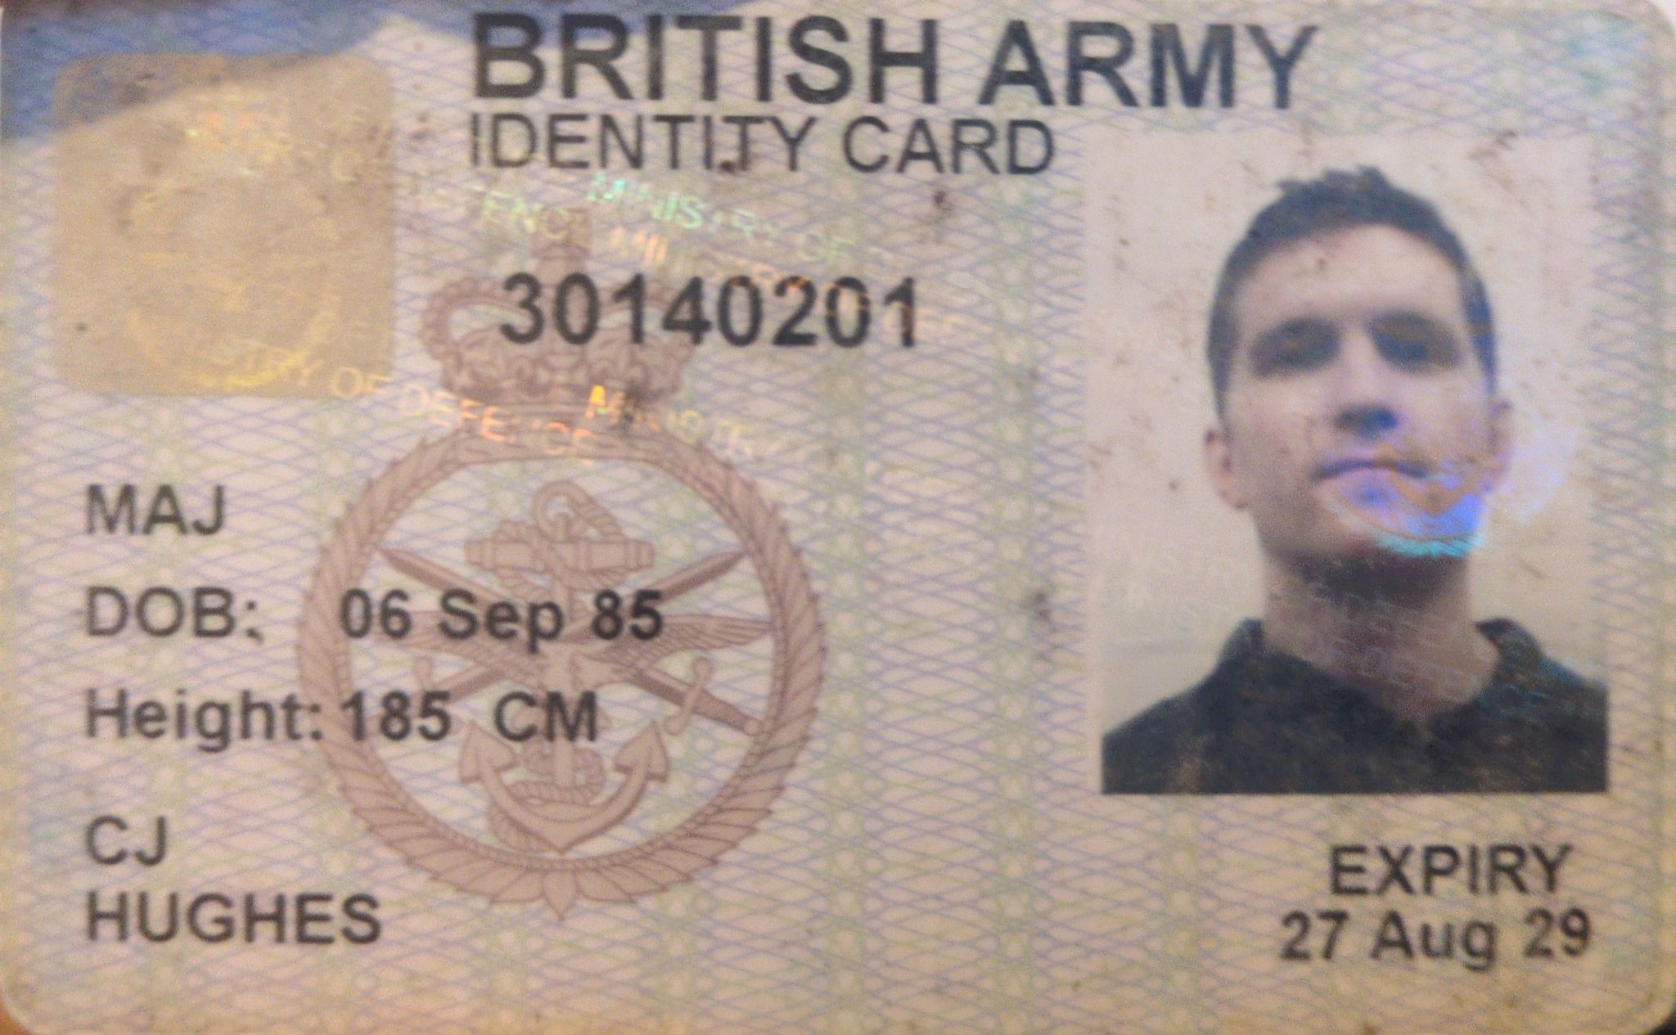

Index No 7

